**ReassignAreaidTest  
09/11/2020 22:41:33**  
User Is Navigated To Site : http://172.19.9.53/ICRARevamp/#/login  
  
*****ReassignAreaidTest is Started *****  
Username is entered  
  
Password is entered  
  
Submit button is clicked  
Text of the element : Successfully logged in  
Successfully logged in  
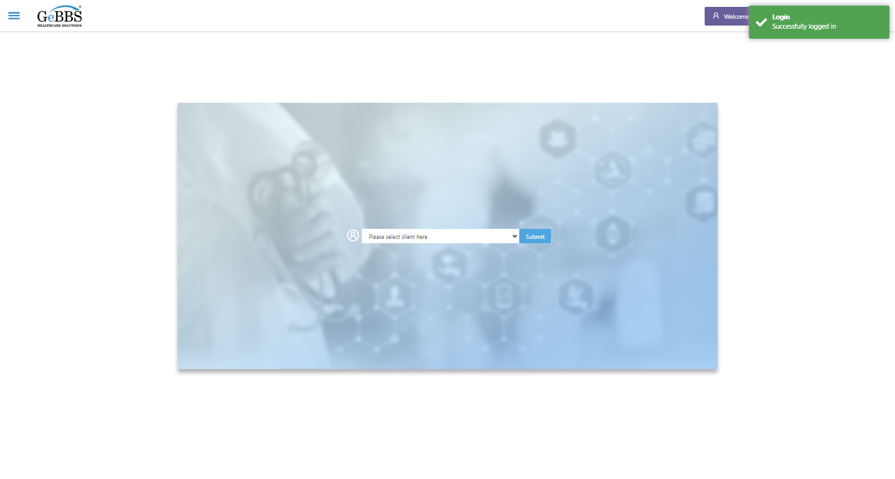  
Client dropdown button is clicked  
Client dropdown button is clicked  
Submit button is clicked  
Main Page loaded  
  
Scrolled successfully  
Call Center is clicked  
All submenus  
  
Submenu in 1 is :Address Allocation  
Submenu in 2 is :Address Approval  
Submenu in 3 is :Address Rollup  
Submenu in 4 is :Data Upload  
Submenu in 5 is :Inbound Call  
Submenu in 6 is :Manager Address Rollup  
Submenu in 7 is :PNP Exception  
Scrolled successfully  
Address Allocation is clicked  
Address Allocation selected  
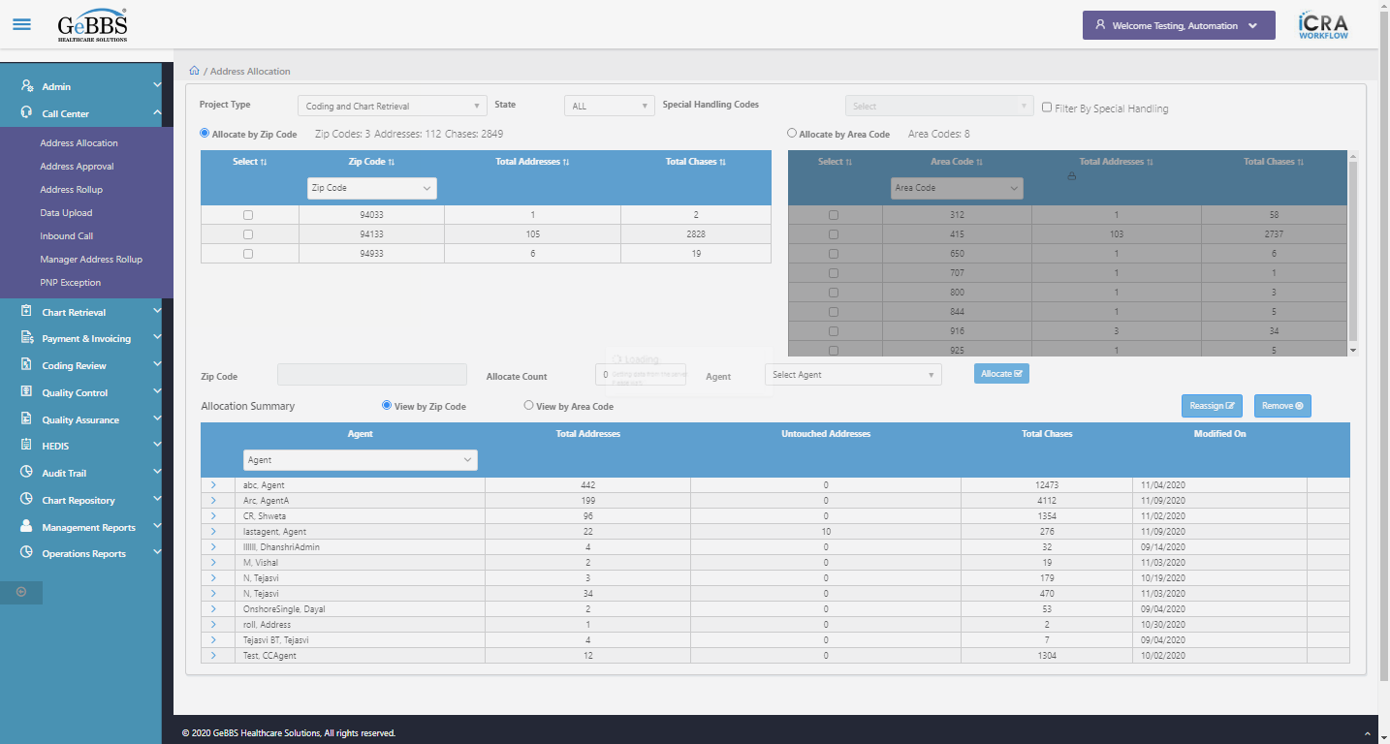  
ViewByAreaRadioButton is clicked  
Area Code Radio Button is clicked  
Agent Found  
Total count of Addresses In Summary Table :0  
Total count of Chases In Summary Table :4112  
Area code1 is clicked  
Code is displayed  
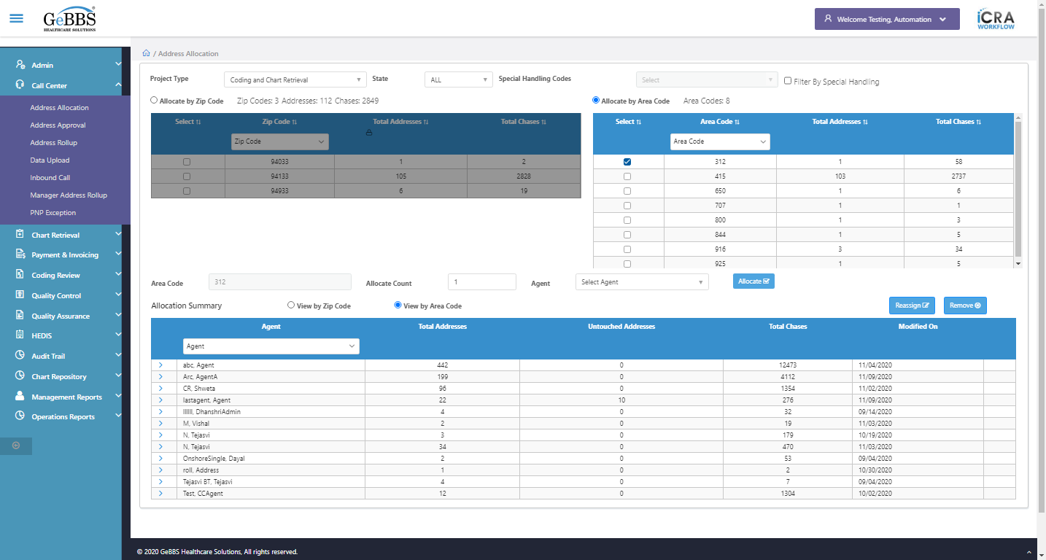  
Allocate Count is enabled  
  
Area code1 is clicked  
Code textbox is blank  
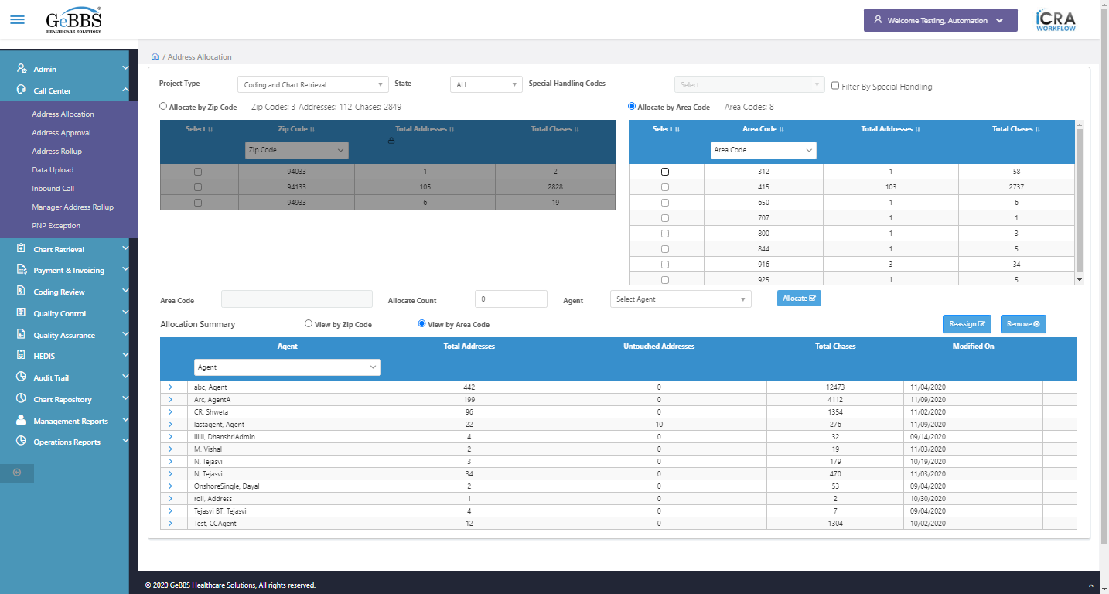  
Area code1 is clicked  
Area code2 is clicked  
Allocate Count is disable  
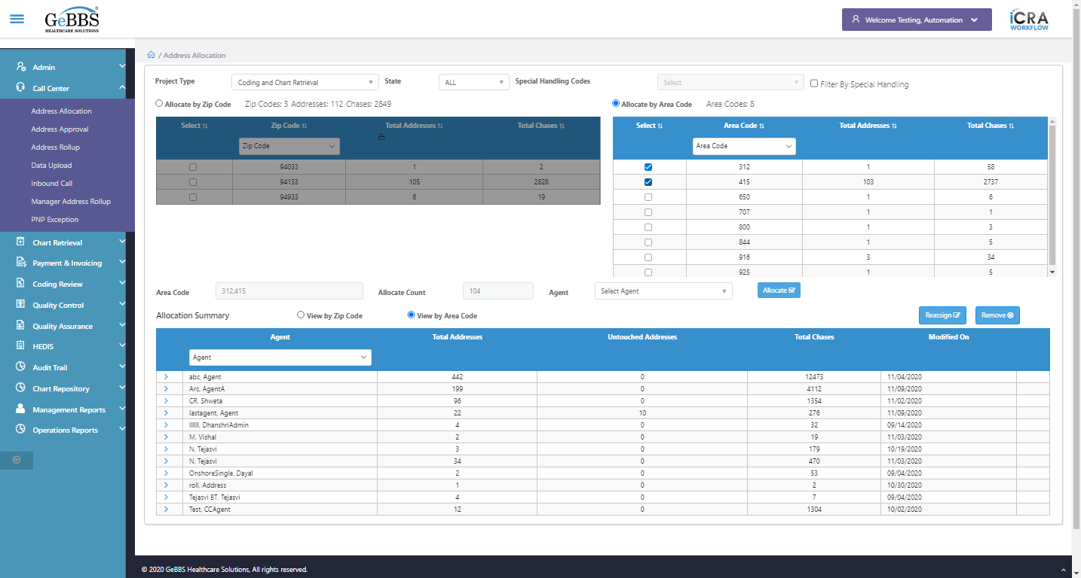  
Taken All counts Of 1st Two Records In Area Code Table  
Total Area Codes Count In Header Before Assign is: 8  
Total Addresses In Header Before Assign is: 112  
Total Chasees In Header Before Assign is: 2849  
1st Area Address Count is:1  
2nd Area Address Count is:103  
Allocate Count and Total Address Count is Equal  
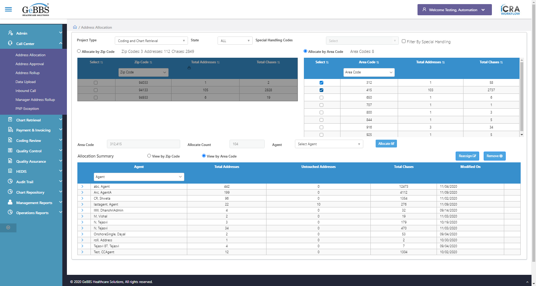  
Agent is clicked  
AgentName is clicked  
Allocate is clicked  
Text Is Correct  
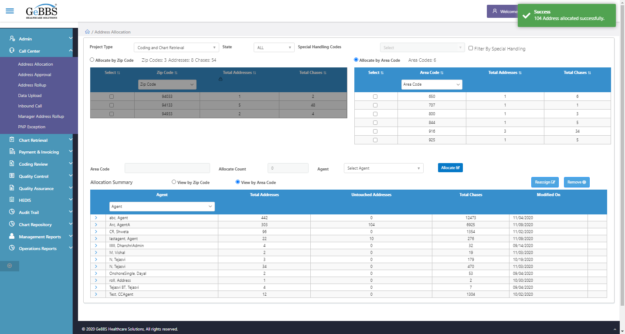  
======== AreaCode is allocated =============  
Count of Area Codes in header is correct  
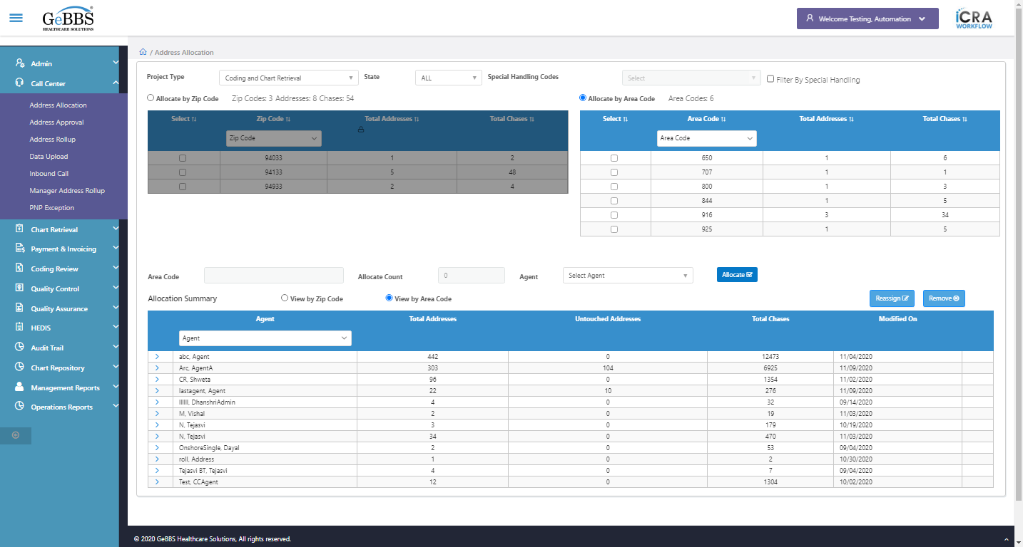  
Area id is assigned and Checked Header Count  
Checked total Untouch address and Total Chase Count in Allocation Summary table after assign   
Scrolled successfully  
> sign is clicked  
Clicked on > sign of that agent  
Code is entered  
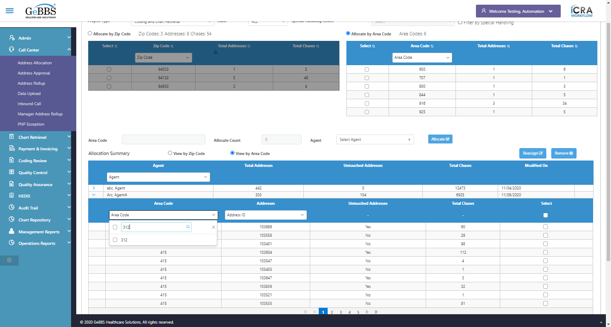  
checkbox is clicked  
Close is clicked  
Id is present in Summary table  
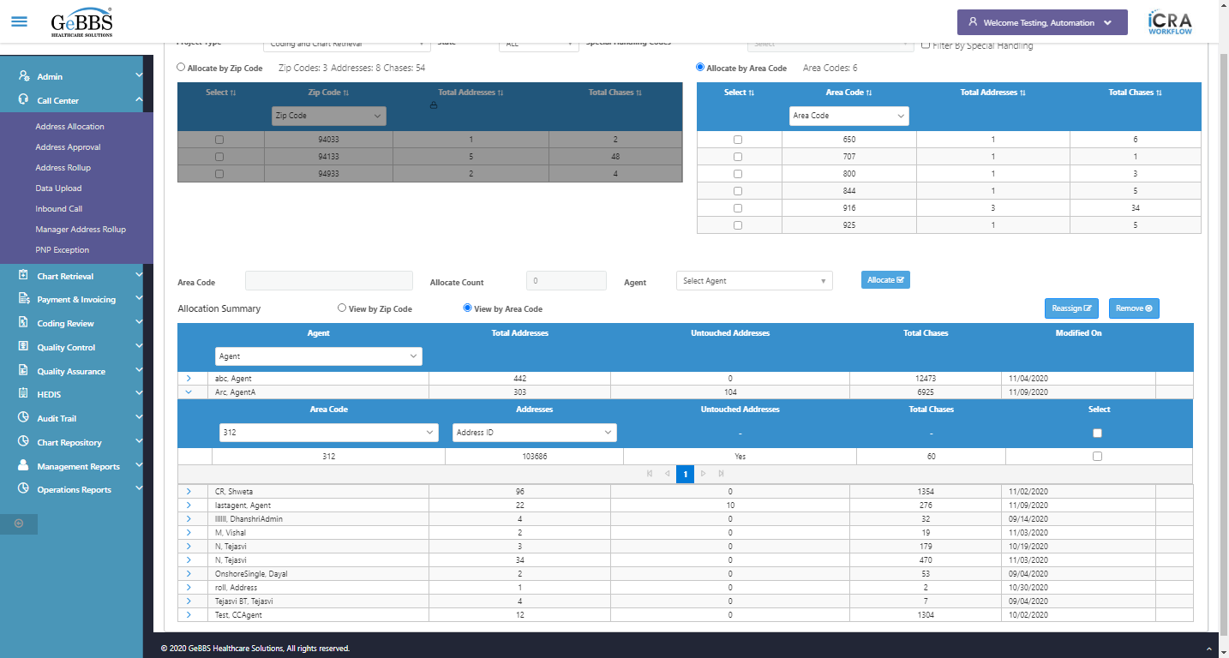  
Checked 1st area id entry in allocation Summary   
ViewByAreaRadioButton is clicked  
Scrolled successfully  
> sign is clicked  
Clicked on > sign of that agent  
Code is entered  
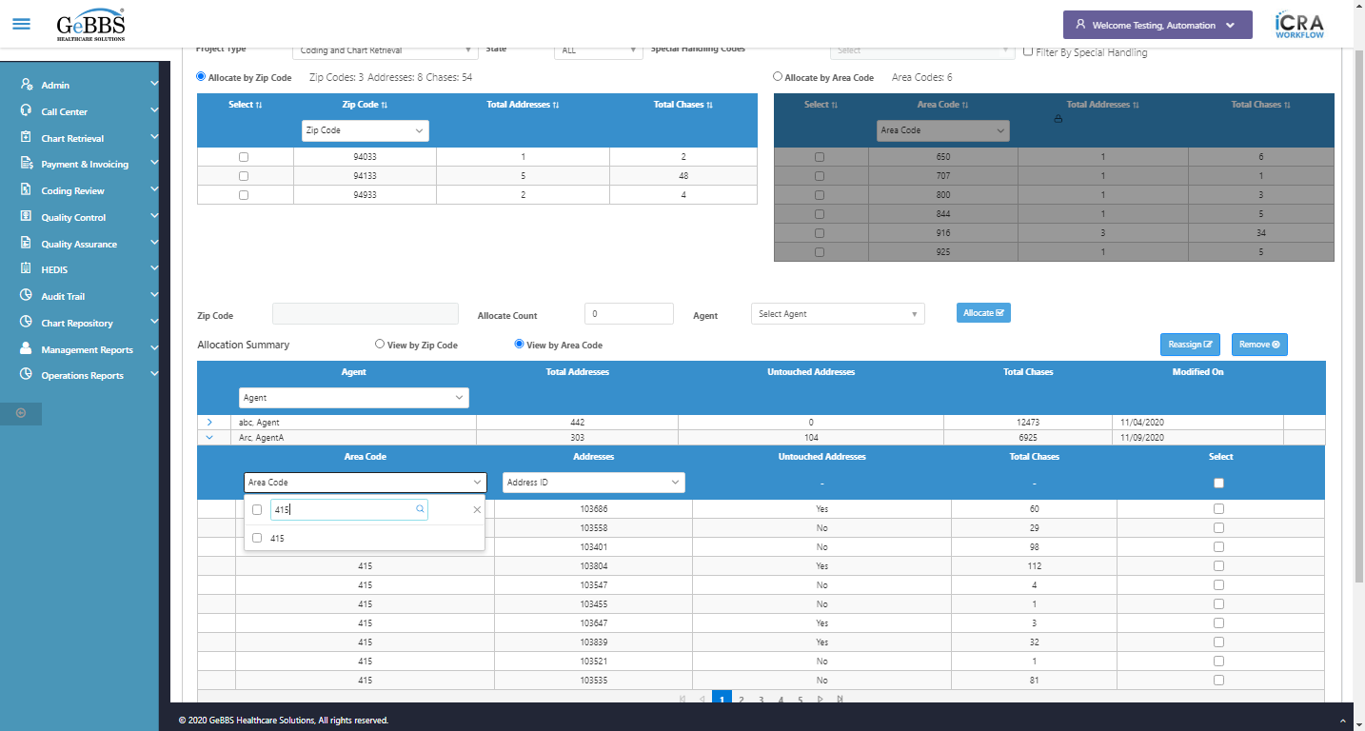  
checkbox is clicked  
Close is clicked  
Id is present in Summary table  
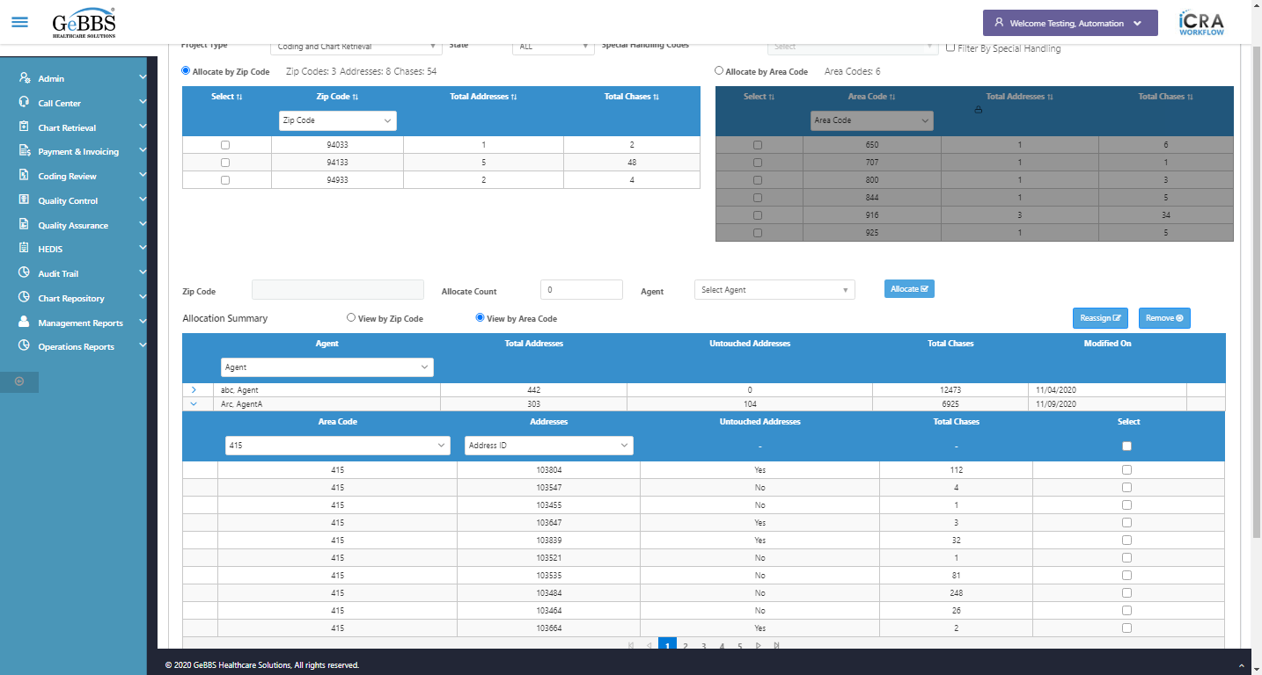  
Checked 2nd area id entry in allocation Summary   
Reassign Flow Started.....  
ViewByAreaRadioButton is clicked  
Agent Found  
Total count of Addresses In Summary Table :104  
Total count of Chases In Summary Table :6925  
Agent Found  
Total count of Addresses In Summary Table :10  
Total count of Chases In Summary Table :276  
Scrolled successfully  
Sign is clicked  
Scrolled successfully  
Scrolled successfully  
Reassign is clicked  
Untouch chase count in reassign winodow is correct  
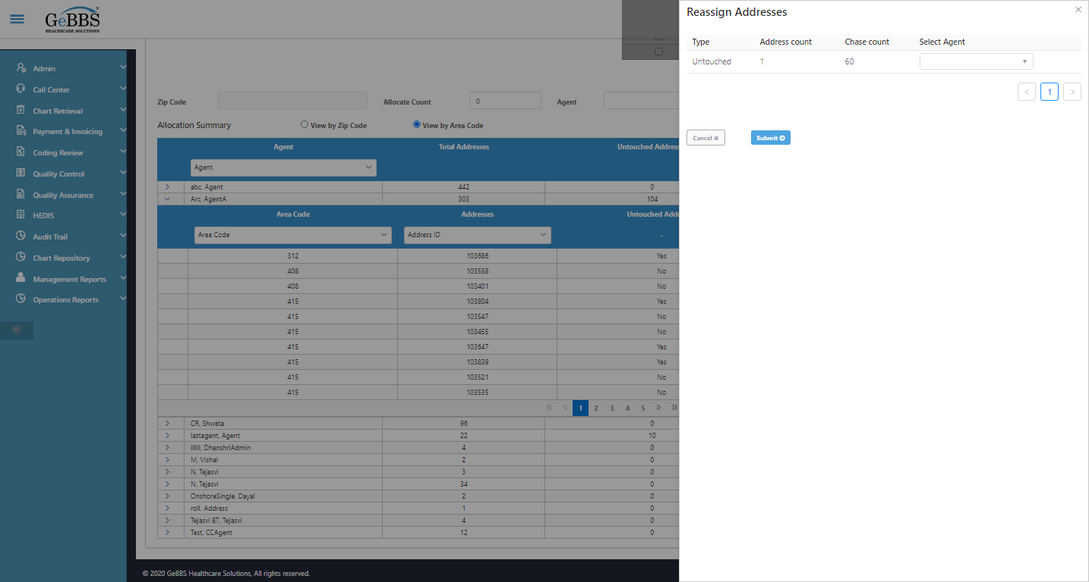  
Checked Untouch chase count in reassign window  
Agent_Reassign is clicked  
AgentName is clicked  
Submit_Reassign is clicked  
Text Is Correct  
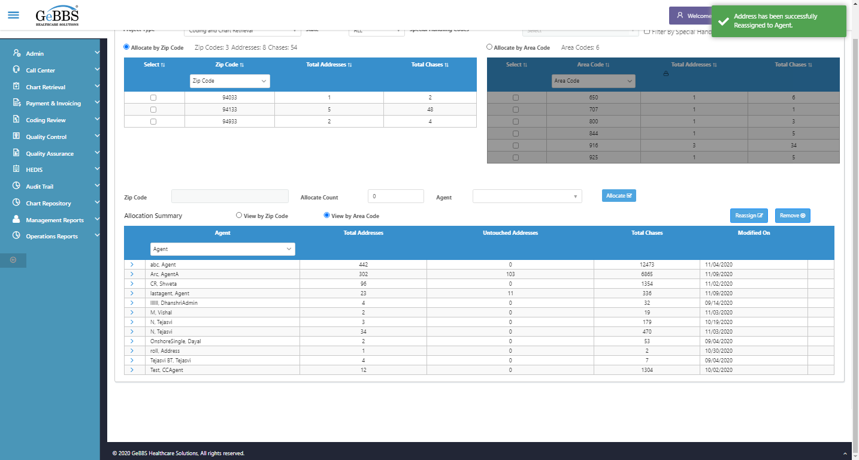  
Agent Found  
Total count of Addresses In Summary Table :103  
Total count of Chases In Summary Table :6865  
Agent Found  
Total count of Addresses In Summary Table :11  
Total count of Chases In Summary Table :336  
Total Untouch Address Count Of Old Agent of Summary table before reassign:104  
Total Untouch Address Count Of Old Agent of Summary table after reassign:103  
Total Untouch Address Count Of New Agent of Summary table before reassign:10  
Total Untouch Address Count Of New Agent of Summary table after reassign:11  
Checking Total Untouched Address Count Of Reassign Agent...........  
Total Untouch address count of new agent after reassign is correct  
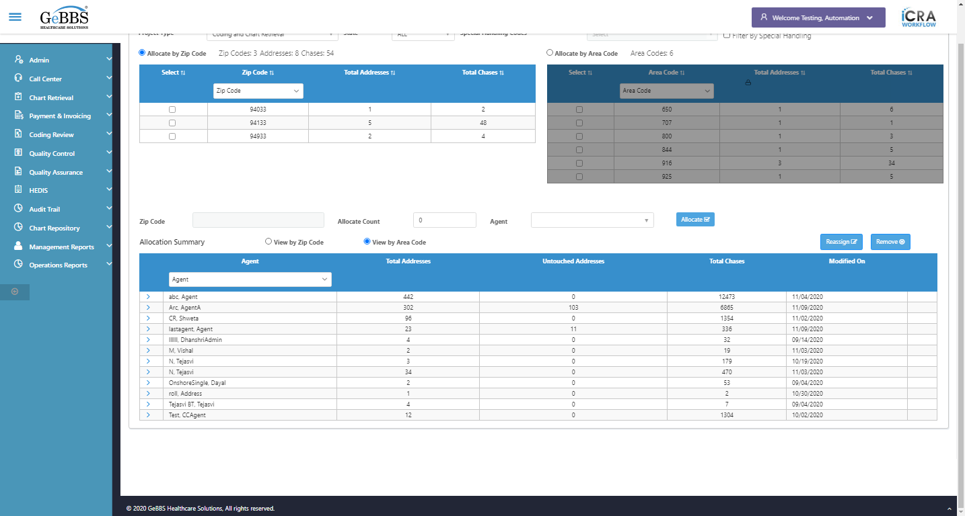  
Checking total Untouched Address Count Of Old Agent...........  
Total Untouch address count of Old agent after reassign is correct  
  
Total Chase Count Of Old Agent of Summary table before reassign:6925  
Total Chase Count Of Old Agent of Summary table after reassign:6865  
Total Chase Count Of New Agent of Summary table before reassign:276  
Total Chase Count Of New Agent of Summary table after reassign:336  
Total Chase Count is correct In Reassign Agent  
  
Checking Total Chase Count Of Old Agent...........  
Total Chase Count is correct In Old Agent  
  
Scrolled successfully  
> sign is clicked  
Clicked on > sign of that agent  
Code is entered  
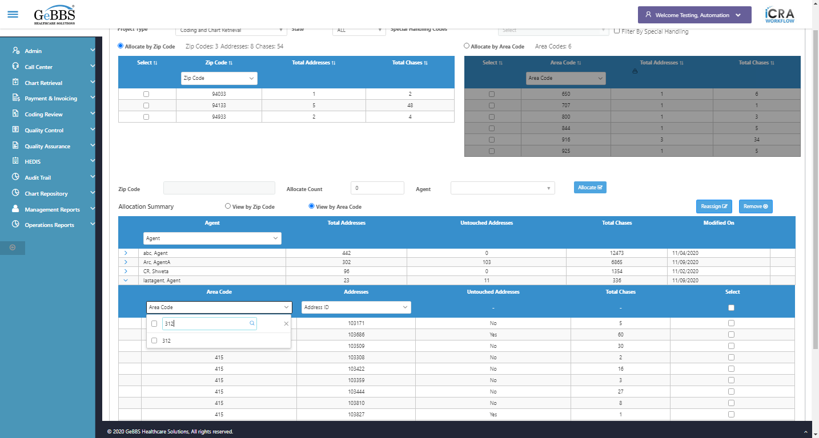  
checkbox is clicked  
Close is clicked  
AddressId is entered  
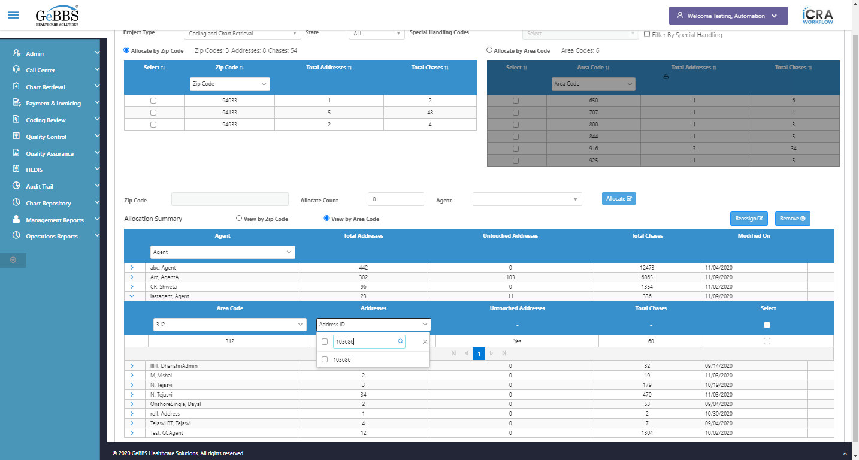  
checkbox is clicked  
Close is clicked  
Id is present in Summary table  
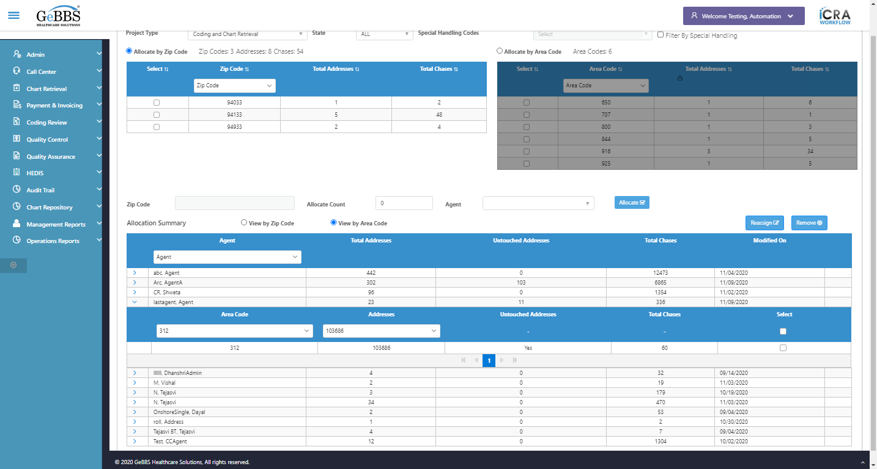  
Address Id in Summary table is correct  
  
Chase count in Summary table is correct  
  
Username is entered  
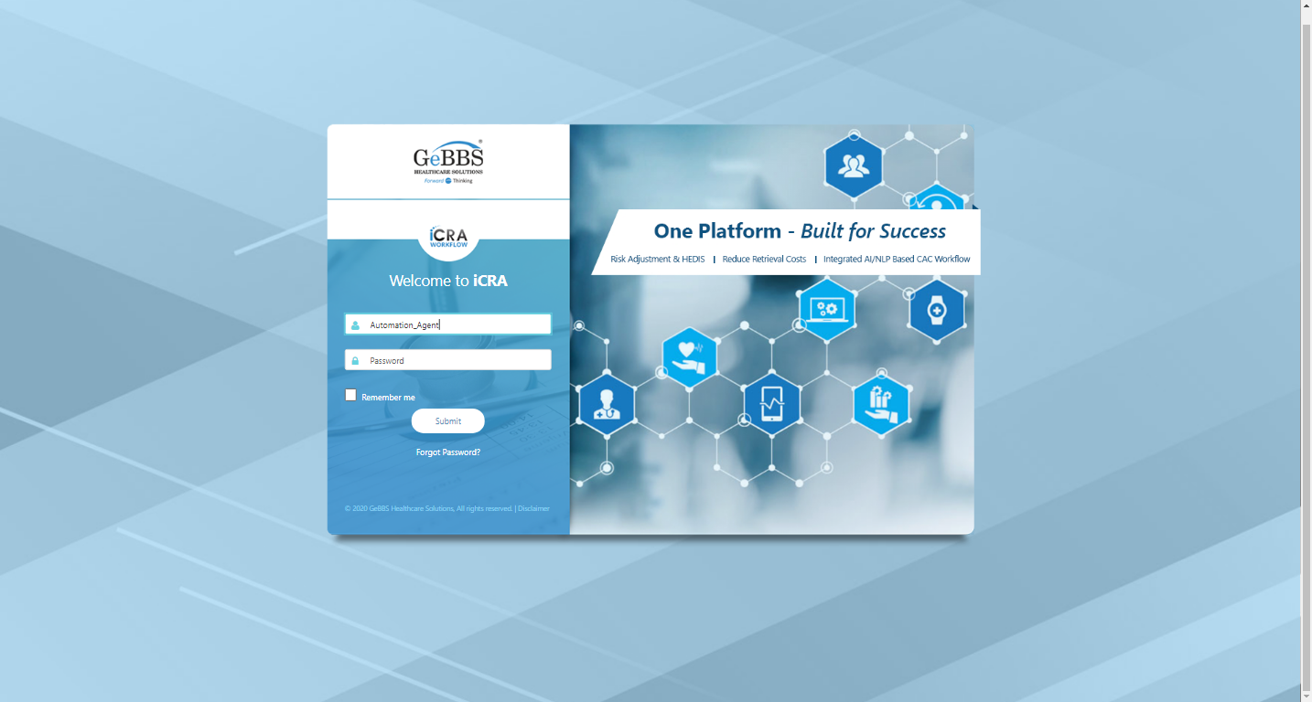  
Password is entered  
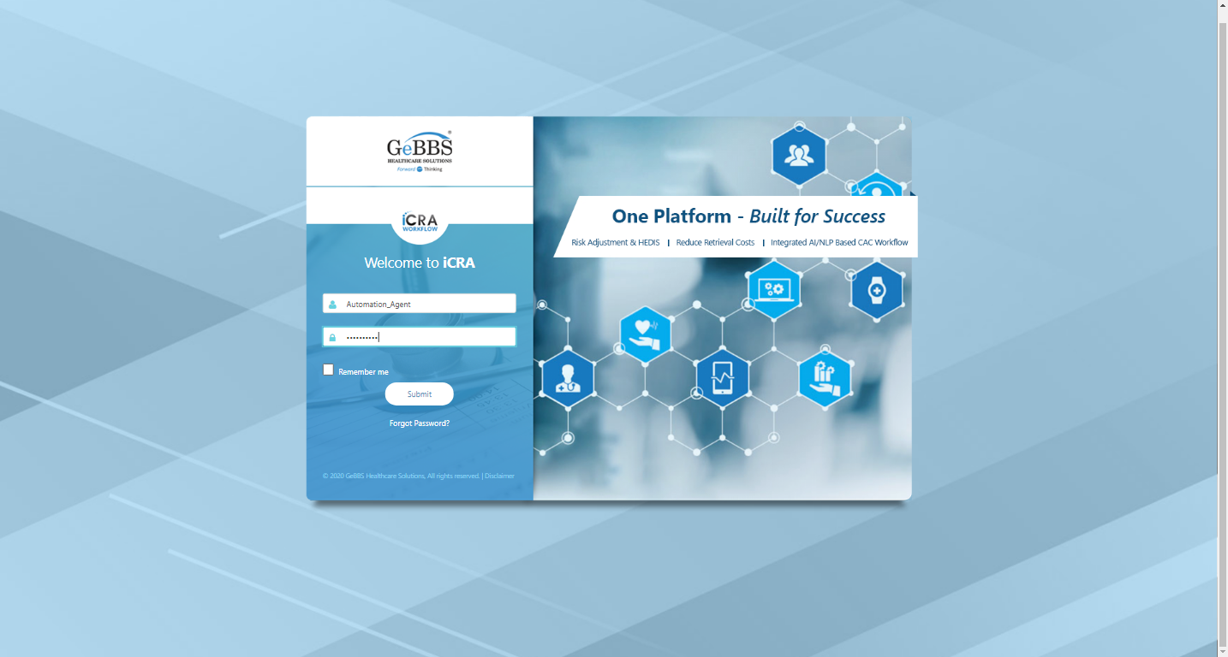  
Scrolled successfully  
Submit button is clicked  
Client dropdown button is clicked  
Client dropdown button is clicked  
Submit button is clicked  
Mainmenu is clicked  
Submenu is clicked  
Address Allocation is selected  
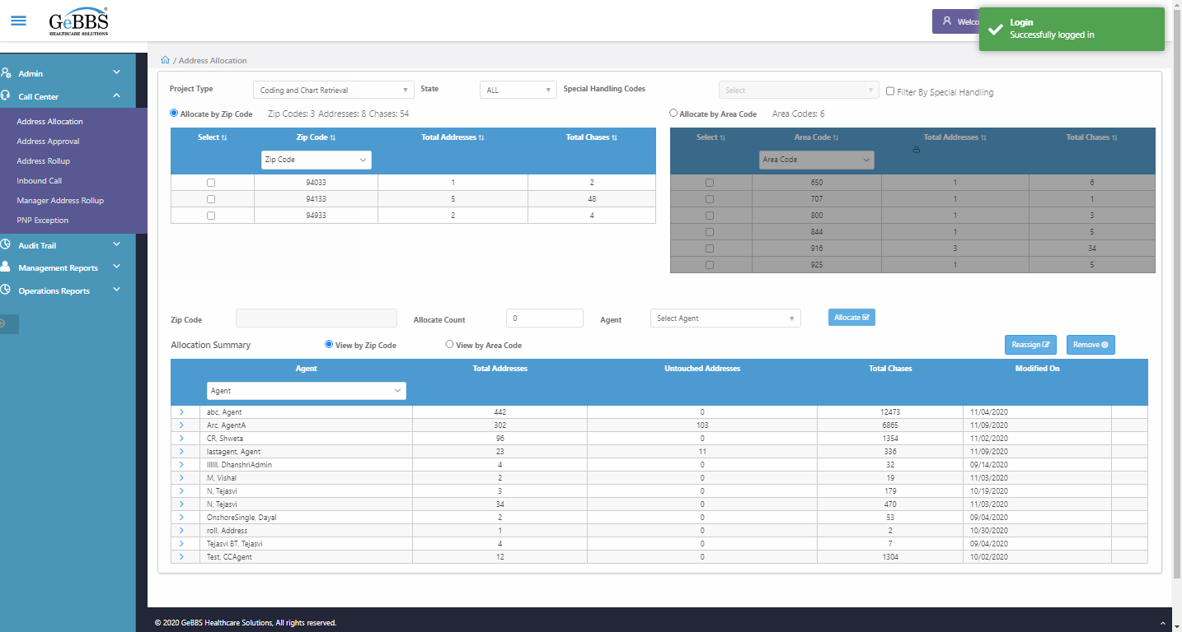  
Address Rollup is clicked  
Element is clicked  
Address id is clicked  
addresstextbox is entered  
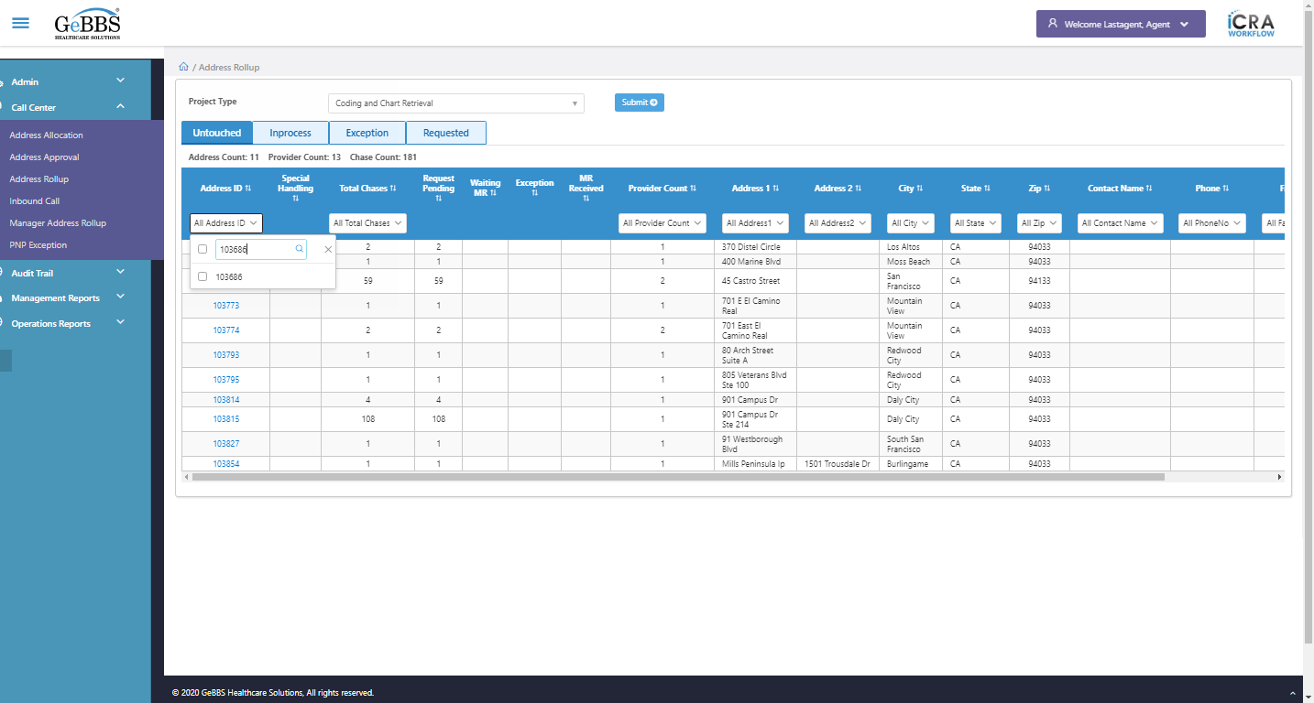  
chkbox1 is clicked  
AddressId is present in RollUp  
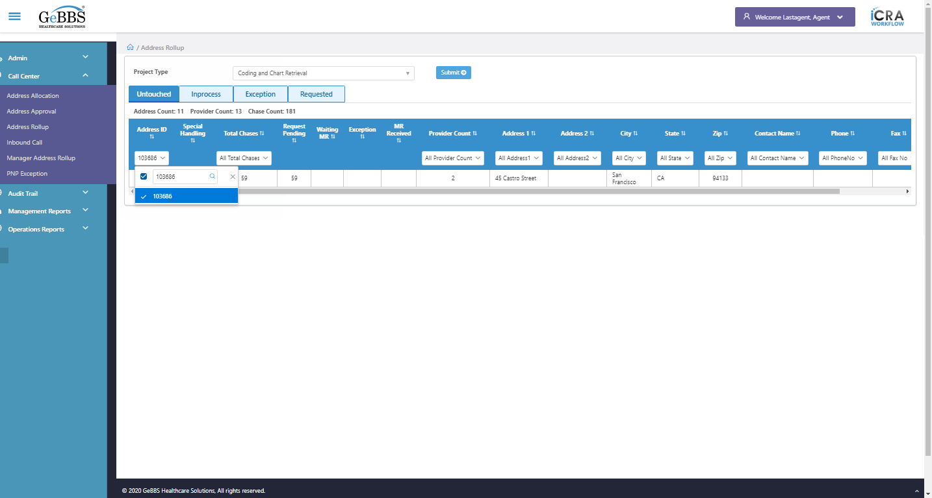  
close is clicked  
Checked Details in reassign agent in summary table  
Reassign Flow Ended.....  
*****ReassignAreaidTest is Ended ***** **09/11/2020 22:44:40**